Science Progression of Knowledge, Skills and Enquiry.

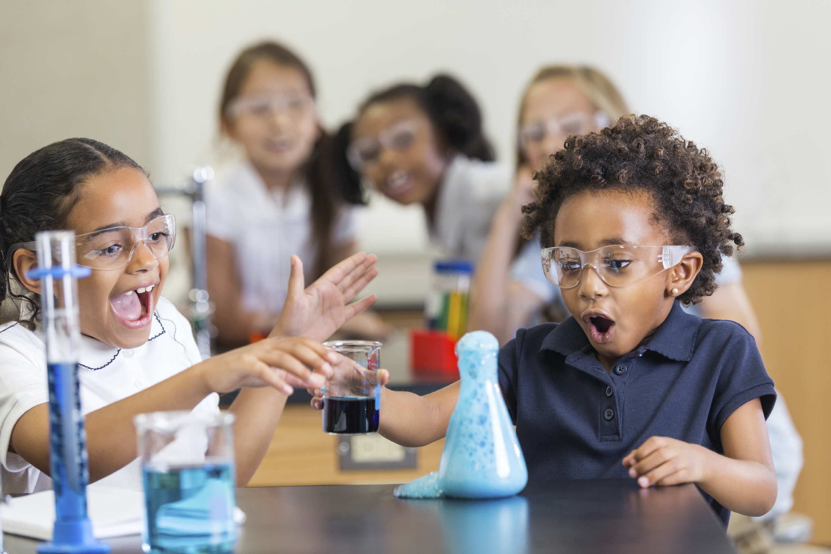

Updated 7.11.22 (EYFS statements)

Science Progression of Knowledge, Skills and Enquiry
How this document works:
This is a whole school overview. The accompanying document shows each year group along with suggested activities and links teachers can use to teach each skill, knowledge or enquiry type.
Page 1: demonstrates what a typical scientist will look like at the end of each year, combining the key skills and knowledge they will require.
Page 2: onwards has the National Curriculum objectives for each year group with key vocabulary for that module and also ‘key indicators’ which demonstrates what the children should know to achieve the objective.
Any text boxes in a different colour with a thick border shows that this skill/knowledge is taught in a different module but builds on from learning in that module e.g.
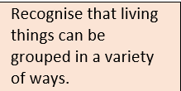
The red writing in brackets underneath show where this objective was taken from. This is to allow teachers to make the links to prior learning.

This grid shows the types of enquiry suggested for each unit. The additional year group document gives suggested activities linked to each ‘scientific enquiry’.
Scientific Enquiry

Research

Pattern Seeking

Observing (Over time)
Testing

Identifying and Classifying

Problem solving
This is the National Curriculum Working Scientifically objectives. These are highlighted through the document in purple. This is to ensure teachers are teaching knowledge alongside skills.
Year 1 / 2 Working Scientifically
Asking simple questions and recognising that they can be answered in different ways ♣ observing closely, using simple equipment ♣ performing simple tests ♣ identifying and classifying ♣ using their observations and ideas to suggest answers to questions ♣ gathering and recording data to help in answering questions.
Year 3 / 4 Working Scientifically
Asking relevant questions and using different types of scientific enquiries to answer them ♣ setting up simple practical enquiries, comparative and fair tests ♣ making systematic and careful observations and, where appropriate, taking accurate measurements using standard units, using a range of equipment, including thermometers and data loggers ♣ gathering, recording, classifying and presenting data in a variety of ways to help in answering questions ♣ recording findings using simple scientific language, drawings, labelled diagrams, keys, bar charts, and tables ♣ reporting on findings from enquiries, including oral and written explanations, displays or presentations of results and conclusions ♣ using results to draw simple conclusions, make predictions for new values, suggest improvements and raise further questions ♣ identifying differences, similarities or changes related to simple scientific ideas and processes ♣ using straightforward scientific evidence to answer questions or to support their findings.
Year 5/6 Working Scientifically
Planning different types of scientific enquiries to answer questions, including recognising and controlling variables where necessary ♣ taking measurements, using a range of scientific equipment, with increasing accuracy and precision, taking repeat readings when appropriate ♣ recording data and results of increasing complexity using scientific diagrams and labels, classification keys, tables, scatter graphs, bar and line graphs ♣ using test results to make predictions to set up further comparative and fair tests ♣ reporting and presenting findings from enquiries, including conclusions, causal relationships and explanations of and degree of trust in results, in oral and written forms such as displays and other presentations ♣ identifying scientific evidence that has been used to support or refute ideas or arguments.

 | Foundation/  EYFS | Year 1 | Year 2 | Year 3 | Year 4 | Year 5 | Year 6
This is what our scientists can do…. | Children will ask questions about the environment including the weather outside. They will be able to suggest what they might wear. They will develop an understanding of growth, decay and changes over time and show care and concern for living things and the environment. They will use their senses when walking around and investigating. They will develop questioning and curiosity through play and understand the concept of forces and electricity through twisting, pushing, slotting and magnetic toys and seeing the effects of pushing different buttons to make sounds and movements. They can talk about similarities and differences between living things and materials and make simple observations about animals. | Children will be asking questions about the local environment including plants and animals found there including how they can look after them. They will observe and talk about the weather and changes. They will explore different materials using scientific language to describe them. | Children will be asking questions about the local environment including discussing how plants grow, survive, germinate and reproduce. They investigate different habitats (incl. micro) and observe how different animals depend on each other and its life processes. They understand basic needs of animal survival including exercise and nutrition. They can identify properties of materials and state why they are suited to purpose. They can name some scientists who have developed new materials. | Children will be asking questions about the local environment and using their observation skills to identify parts of a flower and know how water transports around the plant. Children will understand the lifecycle of a plant by drawing diagrams and using research to find the function of each part. Children will know that humans and animals have skeletons and understand why. They know how humans get nutrients. They will carry out comparative and fair tests to compare and classify rocks and soils based on their properties. | Children will be asking questions about the local environment and observe how the environment can change along with the dangers this can cause. They will understand the functions of the teeth and the importance of oral hygiene. Children will know about how the digestive system works. Children will be grouping, identifying and classifying living things and materials and using classification keys. Children will understand the water cycle and effect of heat with evaporation and condensation as well as materials changing state. Children will use representations to understand how we hear through vibrations and know how to create simple circuits including a switch. Comparative and fair tests will be used to test conductivity of materials. | Children will understand the changes that occur in humans from birth to old age and understand reproduction in plants and animals. They explore different lifecycles and can understand the similarities and differences between mammals, amphibians, insects and birds. Children will be able to explain the uses of everyday materials and describe some reversible and irreversible changes. They will be able to present their results from fair tests using tables and charts. Children will use diagrams to show the movement of the Earth and the moon and can explain how different time zones occur. They explain day and night. They will have an understanding of forces including gravity, air resistance, water resistance and friction. They will be able to mechanisms such a levers, pulleys and gears to explain forces and making jobs easier. | Children will understand how the circulatory system works and will be able to use this to explain the positive and negative effects of diet, exercise, drugs and lifestyle on the body. They will be able to recall animals from the 5 vertebrate group and some from non-vertebrate groups including their key characteristics. They will understand how plants and animals are suited to their environment and the process of evolution. Children will be able to use classification keys to identify unknown plants. They will know what fossils are and can use research and observations to show that things lived billion years ago. Children will use diagrams to explain how light travels and understand shadows. They will be able to make simple circuits using recognised symbols in their drawings. They can conduct a range of fair tests identifying cause and effect when testing brightness of a bulb or volume of a buzzer. Children will be able to conduct a range of investigations with accuracy using repeat measurements and using a range of equipment. They will use scientific theory to refute or support their arguments.
Year Group | EYFS | Year 1 | Year 2 | Year 3 | Year 4 | Year 5 | Year 6
Plants  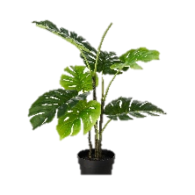 | Natural world  Explore the world around them making observations and drawings of plants.  Natural world  Know some similarities and differences between the natural world around them and contrasting environments, drawing on their experiences and what has been read in class.  Communication and language- express their ideas and feelings about their experiences using full sentences. | - Name common plants and describe the basic structure of flowering plants, including deciduous and evergreen.  - Identify and describe the basic structure of a variety of common flowering plants, including trees. | - Observe and describe how seeds and bulbs grow into mature plants.  - Find out and describe how plants need water, light and a suitable temperature to grow and stay healthy. | - Identify and describe the functions of different parts of flowering plants: roots, stem/trunk, leaves and flowers.  - Explore the requirements of plants for life and growth (air, light, water, nutrients from soil, and room to grow) and how they vary from plant to plant.  - Investigate the way in which water is transported within plants.  - Explore the part that flowers play in the life cycle of flowering plants, including pollination, seed formation and seed dispersal. | (living things and habitats) | 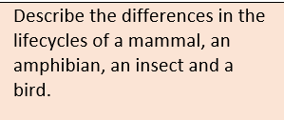  (Living things and habitats) | 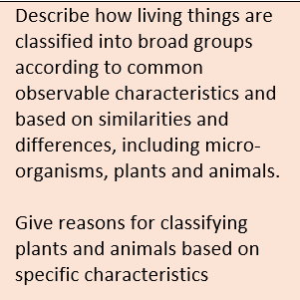  .  (Living things and habitats)  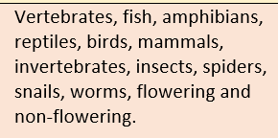
Key vocabulary | Plant, leaf, stem, flower, grow, rain, sun, water, soil, seed, | Leaf, flower, blossom, petal, fruit, berry, root, seed, trunk, branch, stem, bark, stalk, bud.  Names of trees in local area, garden and wild flowering plants. | As year 1+ light, shade, sun, warn, cool, water, grow, healthy. | Photosynthesis, pollen, insect/wind pollination, seed formation, seed dispersal- wind dispersal, animal dispersal, water dispersal, pollen, roots, stem, trunk, leaves, absorb, nutrients, reproduce, germination, stamen, style. | 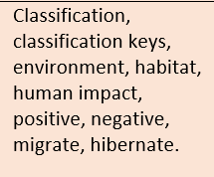  (living things and habitats) | 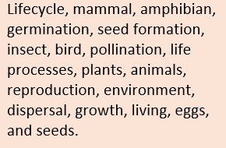  (living things and habitats) | (living things and habitats)
Key indicators | - Can plant seeds and care for growing plants.  - Understand the basic features of a simple plant lifecycle.  - Can name basic parts of a plant e.g. leaf, petal. | - Can name trees and other plants they see regularly.  - Can describe key features of the trees and plants e.g. shapes of leaves/colour of the flower/blossom.  - Can point out trees which lost their leaves and those who keep them all year. Can point to and name parts of a plant.  - Can use simple charts to sort. Can use photos to talk about how plants change. | - Can describe how plants that have grown from seeds and bulbs have developed over time.  - Can identify plants that grew well in different conditions.  - Can spot similarities and differences between bulbs and seeds.  - Can nurture seeds and bulbs into mature plants identifying the different requirements of different plants. | - Can explain the function of the parts of a flowering plant.  - Can describe the life cycle of flowering plants, including pollination, seed formation, seed dispersal and germination.  - Can give different methods of pollination and seed dispersal, including examples.  - Can explain observations made during investigations.  - Can look at features of seeds to decide on method of dispersal.  - Can draw and label a diagram of their created flowering plant to show its parts and their role and method of pollination and seed dispersal. | See living things and habitats. | See living things and habitats. | See living things and habitats.
Animals including humans.  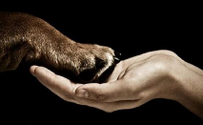 | The Natural World  Explore the natural world around them, making observations and drawing pictures of animals.  Begin to make sense of their own life-story and family’s history.  Begin to understand the key features of the lifecycle of a plant and animal.  People, culture and communities  Describe their immediate environment using knowledge from observation, discussion, stories and non-fiction texts and maps.  Personal, social and emotional development  Manage their own basic hygiene and personal needs, including dressing, going to the toilet and understanding the importance of healthy food choices. | Identify and name a variety of common animals including fish, amphibians, reptiles, birds and mammals.  Identify and name a variety of common animals that are carnivores, herbivores and omnivores.  Describe and compare the structure of a variety of common animals (fish, amphibians, reptiles, birds and mammals, including pets)  Identify, name, draw and label the basic parts of the human body and say which part of the body is associated with each sense | Notice that animals, including humans, have offspring which grow into adults.  Find out about and describe the basic needs of animals, including humans, for survival (water, food and air)  Describe the importance for humans of exercise, eating the right amounts of different types of food, and hygiene. | Identify that animals, including humans, need the right types and amount of nutrition, and that they cannot make their own food; they get nutrition from what they eat.  Identify that humans and some other animals have skeletons and muscles for support, protection and movement. | Describe the simple functions of the basic parts of the digestive system in humans.  Identify the different types of teeth in humans and their simple functions.  Construct and interpret a variety of food chains, identifying producers, predators and prey. | 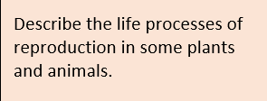  (living things and habitats) | Recognise the impact of diet, exercise, drugs and lifestyle on the way their bodies function.  Identify and name the main parts of the human circulatory system and describe the function of the heart, blood vessels and blood.  Describe the ways in which nutrients and water are transported within animals, including humans.
 |  |  |  |  |  | Describe the changes as humans develop from birth to old age.
Key vocabulary | Head, body, eyes, ears, mouth, teeth, leg, tail, wing, claw, fin, scales, feathers, fur, beak, paws, hooves, heart, | Head, body, eyes, ears, mouth, teeth, leg, tail, wing, claw, fin, scales, feathers, fur, beak, paws, hooves, reptile, amphibian, mammal, omnivore, carnivore, herbivore, all senses. | Offspring, grow, adults, nutrition, reproduce, survival, water, food, air, exercise, hygiene, survival, exercise. | Nutrition, nutrients, carbohydrates, sugars, protein, vitamins, minerals, fibre, fat, water, skeleton, bones, muscles, support, protect, skull, ribs, spine, muscles, joints. | Digestive system, digestion, mouth, teeth, saliva, oesophagus, stomach, small intestine, nutrients, large intestine, rectum, anus, incisor, canine, herbivore, omnivore. | Puberty, vocabulary linked to describe a range of sexual characteristics. | Heart, pulse, rate, pumps, blood, blood vessel, transported, lungs, oxygen, carbon dioxide, nutrients, water, muscles, cycle, circulatory system, diet, exercise, drugs, lifestyle.
Key indicators | Children can explore the natural world around them.  They can describe what the see, feel and hear when outside.  They can recognise environments which is different to the one they live in.  They can talk about simple similarities and differences between living things. They can make simple observations about animals and explain why some things occur.  They can explore basic lifecycles of animals. | Can name a range of animals which includes animals from each of the vertebrate groups.  Can describe the key features of named animals.  Can label key features on a picture/diagram.  Can write descriptively about an animal.  Can write a ‘What am I? riddle about an animal.  Can describe what a range of animals eat.  Can compare and classify animals. | Can sequence the stages of a baby. Observe these changes.  Can describe how animals change as they get older.  Develops understanding of how insects change (more than a butterfly) through lifecycle diagrams.  Can explain what humans and other animals need to survive- this could be through planning a trip to the moon or desert Island.  Can describe how to keep clean and healthy. Has a good understanding of the food plate and understands ‘a healthy balanced diet’. Can create a diet for an athlete. Can adopt a menu to substitute food from the eat well plate. Understands the effect of exercise on the body. | Can name the nutrients found in food. Can state that to be healthy we need to eat the right types of food to give us the correct amount of these nutrients. Name some bones that make up the skeleton giving examples that support, help them move or provide protection. Can describe how muscles and joints help them to move. Classify food groups (high/low nutrients), answer q’s about nutrients in food, use data to look for patterns. Give similarities and differences between skeletons. | Can sequence the main parts of the digestive system. Can draw the main parts of the digestive system onto a human outline. Can describe what happens in each part of the digestive system. Can point to three different types of teeth in their mouth and talk about what each is used for. Demonstrate journey of food through body. Make a dental record, Can explain teeth in animals and if they are carnivores, herbivores or omnivores. | Can explain the changes that takes place in boys and girls during puberty. Can explain how a baby changes physically as it grows and also what it is able to do. | Can draw a diagram of the circulatory system, label the parts and annotate it to show what the parts do. Can explain the positive and negative effects on diet, exercise, drugs and lifestyle on the body.
Living Things | People, culture and communities  Explain some similarities and differences between life in this country and life in other countries, drawing on knowledge from stories, non-fiction texts and maps.  Understanding the world  Begin to understand the need to respect and care for the natural environment and all living things.  Explore the natural world around them. | 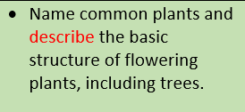  (Plants) | Explore and compare the differences between things that are living, dead, and things that have never been alive. Identify that most living things live in habitats to which they are suited and describe how different habitats provide for the basic needs of different kinds of animals and plants, and how they depend on each other  Identify and name a variety of plants and animals in their habitats, including microhabitats  Describe how animals obtain their food from plants and other animals, using the idea of a simple food chain, and identify and name different sources of food. | 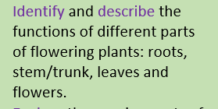  .  (Plants) | Recognise that living things can be grouped in a variety of ways.  Explore and use classification keys to help group, identify and name a variety of living things in their local environment.  Recognise that environments can change and that this can sometimes pose dangers to living things. | Describe the differences in the lifecycles of a mammal, an amphibian, an insect and a bird.  Describe the life processes of reproduction in some plants and animals. | Describe how living things are classified into broad groups according to common observable characteristics and based on similarities and differences, including micro-organisms, plants and animals.  Give reasons for classifying plants and animals based on specific characteristics
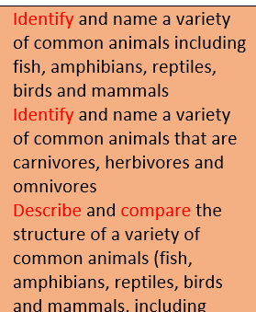

(Animals including Humans)
Evolution and inheritance
Recognise that living things produce offspring of the same kind, but normally offspring vary and are not identical to their parents.
Identify how animals and plants are adapted to suit their environment in different ways and that adaptation may lead to evolution.
Recognise that living things have changed over time and that fossils provide information about living things that inhabited the Earth millions of years ago.

Evolution and Inheritance

Key Vocabulary |  | See Animals including Humans  See Plants | Living, dead, never been alive, suited, suitable, basic need, food, food chain, shelter, move, feed, names of local habitats e.g. pond, woodland, names of micro habitats e.g. under logs, in bushes etc. |  | Classification, classification keys, environment, habitat, human impact, positive, negative, migrate, hibernate. | Lifecycle, mammal, amphibian, germination, seed formation, insect, bird, pollination, life processes, plants, animals, reproduction, environment, dispersal, growth, living, eggs, and seeds. Can dissect and label parts of flowering plant including male and female structures. Record finding as an annotated illustration of a flowering plant. Research and explain the life cycle and reproduction of a plant using scientific language. | Vertebrates, fish, amphibians, reptiles, birds, mammals, invertebrates, insects, spiders, snails, worms, flowering and non-flowering.
Evolution
Offspring, sexual reproduction, vary, characteristics, suited, adapted, environment, inherited, species, fossils.
Key indicators | Children will be able to explore the natural world and make observations.  Children will recognise animal habitats.  Children will understand how to look after animals and the environment including habitats.  Children will begin to explore where they live and compare to other places in the world e.g. weather, climate. |  | Find a range of items which are dead, living. Can name plants/animals which live in different habitats and micro habitat. Can talk about the features of the animal/plant and how they are suited to the habitat. Can talk about what the animal eats. Can construct a food chain. |  | Can name living things in a range of habitats, giving key features that helped identify them. Can give examples of how an environment may change both naturally and due to human impact. Can use classification keys to identify unknown plants and animals. | Can describe the lifecycles of mammals, amphibians and insects using diagrams. Can describe similarities and differences between them. | Can give examples of animals in the five vertebrate groups and some of the invertebrate groups. Can give key characteristics of the five vertebrate groups and some invertebrate groups. Can give examples of flowering and non-flowering plants. Can use classification keys to identify unknown plants and animals. Can create classification keys. Can give a number of characteristics that explain why an animal belongs to a particular group.
Evolution
Can explain the process of evolution. Can give examples of how plants and animals are suited to their environment.
Can give examples of how an animal or plant has evolved over time e.g. penguin, peppered moth. Give examples of things that lived millions of years ago and the fossil evidence to support this.
Materials  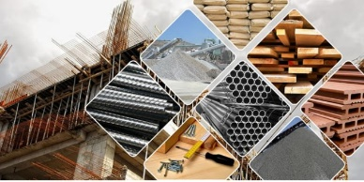 | The Natural World  Understand some important processes and changes in the natural world around them, including changing states of matter.  Speaking  Offer explanations for why things happen, making use of recently introduced vocabulary from stories, non-fiction, rhymes and poems where appropriate.  Understanding of the world  Use all their senses in hands on exploration of natural materials.  Explore collections of materials with similar and/or different properties.  Talk about what they see using a wide vocabulary.  Explore how things work.  Talk about the difference between materials and changes they notice. | Distinguish between an object and the material from which it is made.  Identify and name a variety of everyday materials, including wood, plastic, glass, metal, water, and rock.  Describe the simple physical properties of a variety of everyday materials. Compare and group together a variety of everyday materials on the basis of their simple physical properties. | Identify and compare the suitability of a variety of everyday materials, including wood, metal, plastic, glass, brick, rock, paper and cardboard for particular uses.  Find out how the shapes of solid objects made from some materials can be changed by squashing, bending, twisting and stretching. | 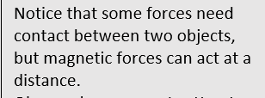  (Forces and magnetism) | STATES OF MATTER  Compare and group materials together, according to whether they are solids, liquids or gases (states of matter)  Observe that some materials change state when they are heated or cooled, and measure or research the temperature at which this happens in degrees Celsius (States of matter)  Identify the part played by evaporation and condensation in the water cycle and associate the rate of evaporation with temperature.  (states of matter) | Compare and group together everyday materials on the basis of their properties, including their hardness, solubility, transparency, conductivity (electrical and thermal) and response to magnets.  Know that some materials will dissolve in liquid to form a solution, and describe how to recover a substance from a solution.  Use knowledge of solids, liquids gases to decide how mixtures might be separated, including through filtering, sieving and evaporating.  Give reasons, based on evidence from comparative and fair tests, for the particular uses of everyday materials, including metals wood and plastic.  Demonstrate that dissolving, mixing and changes of state are reversible changes.  Explain that some changes result in the formation of new materials and this kind of change is not usually reversible, including changes associated with burning and the action of acid on bicarbonate of soda. | 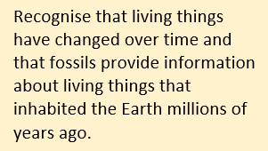  (Evolution and Inheritance)
Rocks and Soils  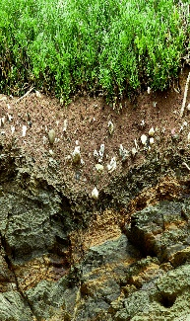 |  |  |  | Rocks and Soils  Compare and group together different kinds of rocks on the basis of their appearance and simple physical properties.  Describe in simple terms how fossils are formed when things that have lived are trapped within a rock.  Recognise that soils are made from rocks and organic matter
Key Vocabulary | Wet, dry, shiny, dull, bendy, stiff, squashy, hard/soft, lumpy, wrinkly. Smooth, rough. | Object, material, wood, plastic, glass, metal, water, rock, brick, paper, fabric, elastic, foil, card/cardboard, rubber, wool, clay, hard, soft, stretchy, stiff, bendy, floppy, waterproof, absorbent, breaks/tears, rough, smooth, shiny, dull, see through, not see through. | Names of materials: wood, plastic, glass, metal, water, rock, brick, paper, fabric, card, rubber, suitable/unsuitable, use/useful, hard/soft, stretchy/stiff. Rigid/flexible, waterproof/absorbent, strong/weak, rough/smooth, transparent/opaque, shape, push/pushing, pull/pulling, twist/twisting, squash/squashing, bend/bending, stretch/stretching. | Rock, stone, pebble, boulder, grain, crystals, layers, hard, soft, texture, absorb, water, soil, fossil, marble, chalk, granite, sandstone, slate, soil, peat, sandy/chalk/clay soil. | Solid, liquid, gas, state change, melting, freezing, melting point, boiling point, evaporation, temperature, water cycle | Thermal/electrical insulator/conductor, change of state, mixture, dissolve, solution, soluble, insoluble, filter, sieve, reversible/not reversible, change, burning, rusting, new material.
Key indicators | They can talk about simple similarities and differences between two materials and how materials change in terms of shape, size and texture.  They can describe materials using basic scientific words.  They can explore how things work.  They can group and classify materials using their properties. | Can label a picture/diagram of an object made from different materials.  Can describe the properties of materials.  Can sort materials using their properties. Can test evidence to answer a question. | Can name an object, say what material it is made from, identify properties and make a link between property and use. Whilst changing a shape of an object can describe the actions used.  Can use suitable vocabulary. Simple tests relevant to properties. Describe similarities and differences. | Can name some types of rock and give physical features of each. Can explain how a fossil is formed. Can explain that soils are made from rocks and also contain living/dead matter. Classify rocks in a range of ways using scientific vocabulary. Test properties of rocks. Show understanding of how fossils were formed, can identify plant/animal matter in soil, test water retention of soils. | Can create a concept map, including arrows linking the key vocabulary.  Can name properties of solids, liquids and gases.  Can give everyday examples of melting and freezing.  Can give everyday examples of evaporation and condensation.  Can describe the water cycle.  Can give reasons to justify why something is a solid liquid or gas.  Can give examples of things that melt/freeze and how their melting points vary  From their observations, can give the melting points of some materials.  Using their data, can explain what affects how quickly a solid melts.  Can measure temperatures using a thermometer.  Can explain why there is condensation on the inside the hot water cup but on the outside of the icy water cup  From their data, can explain how to speed up or slow down evaporation.  Can present their learning about the water cycle in a range of ways e.g. diagrams, explanation text, story of a water droplet. | Can explain everyday uses of material e.g. how bricks, wood, glass are used in buildings. Can explain what dissolving is, giving examples. Can name equipment used for filtering and sieving. Can use knowledge of liquids, gases and solids to suggest how materials can be recovered from solutions or mixtures by evaporation, filtering or sieving. Can describe simple reversible and non-reversible changes to materials, giving examples.  Can create chart/table grouping materials using properties. Suggest appropriate material for purpose. Can explain results from investigations involving dissolving and non-reversible change.
Seasonal Changes  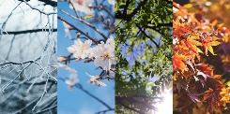 | The Natural World  Understand some important processes and changes in the natural world around them, including seasons. | Observe changes across the four seasons. Observe and describe weather associated with the seasons and how day length varies. |  | 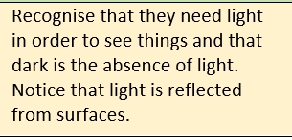  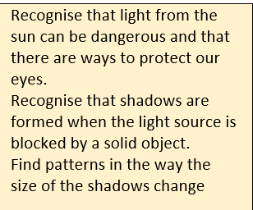  (Light) |  | 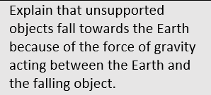  (Forces) | 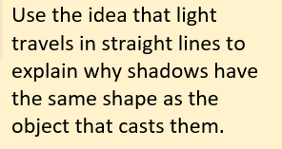  (Light)  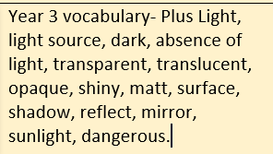
Earth and Space |  |  |  |  |  | Earth and Space  Describe the movement of the Earth and other planets, relative to the sun in the solar system.  Describe the movement of the moon relative to the Earth.  Describe the Sun, Earth and Moon as approximately spherical bodies.  Use Earth rotation to explain day and night due to the apparent movement of the sun across the sky.
Key vocabulary | Snow, wind, rain, sun, day, night, stormy, cloudy, hot, cold, foggy. | Weather (sunny, rainy, windy, snowy etc) Seasons (winter, summer, spring, autumn) sun, sunrise, sunset, Day length |  | 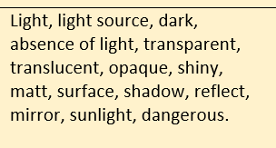  (Light) |  | Earth, sun, moon, Mercury, Jupiter, Saturn, Venus, Mars, Uranus, Neptune, Pluto (dwarf planet), spherical, solar system, rotates, star, orbit, planets, axis, night, day, season, galaxy. Meteorite. | (Light)
Key indicators | Can describe the weather outside and suggest what they might wear and what they might see. Can comment on the environment e.g. the leaves have fallen off the tree, there is a puddle.  Children can understand the effect of changing seasons on the natural world around them. | Can name four seasons and identify when in the year they occur. Can observe and describe weather in different seasons. Can describe days being longer in summer and shorter in winter. Present data in tables charts and compare seasons. |  | See Light |  | Can show using diagrams the movement of the Earth and moon. Can explain the rotation of the Earth and how this causes night and day. Can explain evidence gathered about the position of shadows in terms of movement of the Earth. Can explain how a sundial works. Can explain why we have time zones. | See Light
Light and sound | Understanding of the world  Explore materials with different properties.  Talk about what they see, using a wide vocabulary.  Expressive arts and design  Safely use and explore a variety of materials, tools and techniques, experimenting with colour, design, texture form and function.  Explore colour and colour-mixing.  Play instruments with increasing control to express their feelings and ideas. | 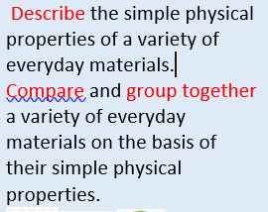  (Materials) | 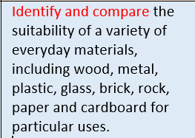  (materials) | 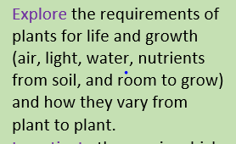  (Plants) | 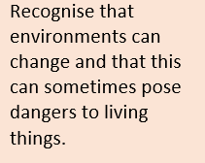  (living things and habitats) | 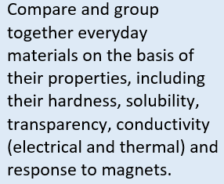  (materials) | Recognise that light travels in straight lines.  Use the idea that light travels in straight lines to explain that objects are seen because they give out or reflect light into the eye.  Explain that we see things because light travels from light sources to our eyes or from light sources to objects and then to our eyes.  Use the idea that light travels in straight lines to explain why shadows have the same shape as the object that casts them.
 |  |  | 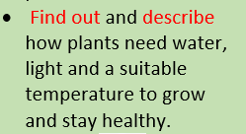  (Plants) | Recognise that they need light in order to see things and that dark is the absence of light.  Notice that light is reflected from surfaces.  Recognise that light from the sun can be dangerous and that there are ways to protect our eyes.  Recognise that shadows are formed when the light source is blocked by a solid object.  Find patterns in the way the size of the shadows change
 |  | 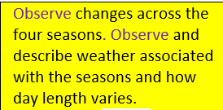  (Seasonal changes) |  |  | SOUND  To identify how sounds are made, associating some of them with something vibrating.  Recognise that vibrations from sounds travel through a medium to the ear.  Find patterns between pitch of a sound and features of the object that produced it.  Find patterns between the volume of a sound and the strength of the vibrations that produced it.  Recognise that sound gets fainter as the distance from the sound source increases. | 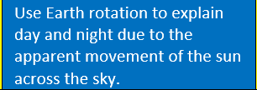  (Earth and Space)
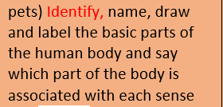

(Animals incl humans)
Key vocabulary | Smell, sound, sight, see, look, | See Seasonal Changes  See Animals Including Humans |  | Light, light source, dark, absence of light, transparent, translucent, opaque, shiny, matt, surface, shadow, reflect, mirror, sunlight, dangerous. | Sound, source, vibrate, vibration, travel, pitch, volume, faint, loud, insulation. | 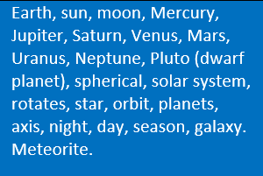  (Earth and Space) | Year 3 vocabulary- Plus Light, light source, dark, absence of light, transparent, translucent, opaque, shiny, matt, surface, shadow, reflect, mirror, sunlight, dangerous.
Key indicators | Children will be able to identify and name different colours. They can mix colours and explain the changes.  They can experiment with sound and making different noises with musical instruments and express using different terms such as loud, quiet, beat, vibrate. | See Seasonal Changes  See Animals Including Humans |  | Can describe how we see objects in lights and can describe dark as the absence of light. Know it is dangerous to look at the sun. Define transparent, translucent and opaque. Can describe how shadows are formed. Predict what materials will be more/less visible. . | Can describe different types of objects producing different sounds and that the sound is produced by vibration in the object. Can describe sounds travelling through different mediums such as air, water, metal. Can find patterns between pitch and volume and the features of the object producing it. Can recognise that sounds get fainter as the distance from the sound source increases.  Can explain what happens when you strike a drum or pluck a string- use diagrams to show. Demonstrates how to increase/decrease pitch and volume. | (See Earth and Space) | Can describe with diagrams how light travels in straight lines, either from sources or reflected from other objects into our eyes. Can describe with diagrams how light travels in straight lines past translucent or opaque objects to form a shadow of the same shape.
Forces  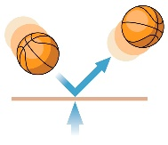 | Understanding the World.  Explore and talk about different forces they can feel.  Can talk about the differences between materials and changes they notice. | 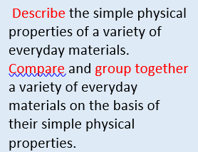  (Materials) | 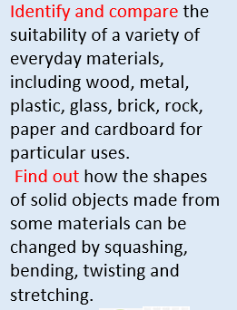  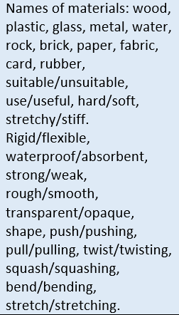  (Materials) | Compare how things move on different surfaces  Notice that some forces need contact between two objects, but magnetic forces can act at a distance.  Observe how magnets attract or repel each other and attract some materials and not others.  Compare and group together a variety of everyday materials on the basis of whether they are attracted to a magnet, and identify some magnetic materials.  Describe magnets as having two poles.  Predict whether two magnets will attract or repel each other, depending on which poles are facing. |  | Explain that unsupported objects fall towards the Earth because of the force of gravity acting between the Earth and the falling object.  Identify the effects of air resistance, water resistance and friction that act between moving surfaces.  Recognise that some mechanisms, including levers, pulleys and gears, allow a smaller force to have a greater effect.
 |  |  |  |  |  | To describe the movements of the Earth, and other planets, relative to the Sun in the solar system (Earth and Space)
Key Vocabulary | Push, pull, twist, stretch, turn, open, lift, squeeze, pinch, flick, tap. | 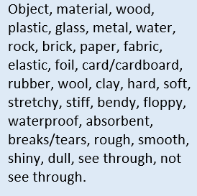  (Materials) | (Materials)  (Materials) | Force, push, pull, twist, contact force, non-contact force, magnetic force, magnet, strength, bar magnet, ring magnet, button magnet, horseshoe magnet, attract, repel. Magnetic material, metal, iron, steel, poles, north pole, south pole. |  | Force, Gravity, Earth, air resistance, water resistance, friction, mechanisms, simple machines, levers, pulleys, gears.
Key indicators | Children will be able to play with a range of toys of varying sizes made of different materials and fit them together in different ways such as twisting, pushing, slotting or magnetism. Can manipulate playdough in different ways. | (See Materials) | (See Materials) | Give examples of forces in everyday life. Give examples of objects moving differently on different surfaces. Name a range of magnets and show how the poles attract and repel. Can draw diagrams using arrows to show the attraction and repulsion between the poles of magnets. Can use results to describe how objects move on different surfaces. Can use results to make predictions. Can use some classification to know some metals are not magnetic. Use test data to rank magnets. |  | Can demonstrate the effect of gravity acting on an unsupported object. Can give examples of friction, water resistance and air resistance. Can give examples of when it is beneficial to have high or low friction, water resistance, and air resistance. Can demonstrate how pulleys, levers and gears work.
Electricity | Shows skills in making toys work by pressing parts or lifting flaps to achieve effects such as sound, movement or new images. | (Materials) | 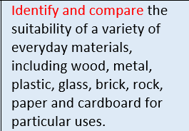  (Materials) |  | Identify common appliances that run on electricity.  Construct a simple series electrical circuit, identifying and naming its basic parts, including cells, wires, bulbs, switches and buzzers.  Identify whether or not a lamp will light in a simple series circuit, based on whether or not the lamp is part of a complete loop with a battery  Recognise that a switch opens and closes a circuit and associate this with whether or not a lamp lights in a simple series circuit.  Recognise some common conductors and insulators, and associate metals with being good conductors. | 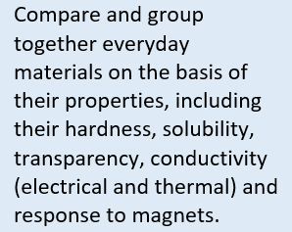  (Materials) | Associate the brightness of a lamp or the volume of a buzzer with the number and voltage of cells used in the circuit.  Compare and give reasons for variations in how components function, including the brightness of bulbs, the loudness of buzzers and the on/off potion of switches.  Use recognised symbols when representing a simple circuit in a diagram.
 |  | (Materials) | (Materials) |  | Can name the components in a circuit. Can make an electric circuit. Can control a circuit using a switch. Can name some metals that are conductors. Can name materials that are insulators.  Can communicate structures of circuits using drawings. Can incorporate a switch. Can add a circuit with a switch to a DT project and demonstrate how it works. Can describe how a switch works. |  | Explain how a circuit operates to achieve particular operations, such as control the light for a torch with different brightnesses or make a motor go faster or slower  Make circuits to solve particular problems such as a quiet and a loud burglar alarm  Carry out fair tests exploring changes in circuits  Make circuits that can be controlled as part of a D&T project
 |  |  |  |  | Electrical, appliance, mains, plug, circuit, component, cell, battery, positive, negative, connect/connectors, loose connection, short circuit, crocodile clip, bulb, switch, buzzer, motor, conductor, insulator, metal, non-metal, symbol. |  | Circuit, complete circuit, circuit diagram, circuit symbol, cell, battery, bulb, buzzer, motor, switch, voltage  NB Children do not need to understand what voltage is but will use volts and voltage to describe different batteries. The words cells and batteries are now used interchangeably

