NEW |  |  | ABINGDON PRIMARY SCHOOL –  Science Yearly overview Cycle A |  |  |  | 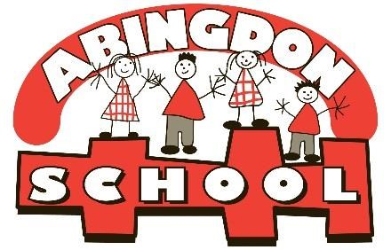
CURRICULUM AREA | FS | YEAR 1 | YEAR 2 | YEAR 3 | YEAR 4 | YEAR 5 | YEAR 6
Autumn 1 | All About Me!  Seasons/weather | Dungeons and Dragons  Animals including humans (Y1) |  | Eureka!  Forces and magnets (Y3) |  | Behind Enemy Lines  Animals, including humans (Y5)
Autumn 2 | Festivals and Celebrations  Seasons/weather | Animals including humans (Y1) |  | Electricity (Y4) |  | Electricity (Y6)
Spring 1 | When I Grow Up…  Seasons/weather  Melting, freezing, floating and sinking.  Habitats | The Secret Garden  Plants (Y1) |  | Globetrotters  Living things and their habitats (Y4) |  | What a Wonderful World!  Living things and their habitats (Y5)
Spring 2 | Who Lives Where?  Seasons/weather  Melting, freezing, floating and sinking.  Habitats | Plants (Y2) |  | Animals including humans (Y3) |  | Living things and their habitats (Y6)
Summer 1 | Growth and Change  Plants and their life cycles  Caring for plants and animals  Observations of plants and animals  Animal life cycles | Gift of Colour  Plants (Y2) |  | Tomb raiders  Animals including humans (Y3) |  | Raiders or Traders  Evolution and inheritance (Y6)
Summer 2 | Once Upon a Time…  Plants and their life cycles  Caring for plants and animals  Observations of plants and animals  Animal life cycles | Seasonal changes (Y1) |  | Animals including humans (Y4) |  | BSW – renewable energy (Y5)

ABINGDON PRIMARY SCHOOL –
Science Yearly overview Cycle B
CURRICULUM AREA | FS | YEAR 1 | YEAR 2 | YEAR 3 | YEAR 4 | YEAR 5 | YEAR 6
Autumn 1 | All About Me!  Seasons/weather | Down in the Deep, Dark Woods  Animals including humans (Y2) |  | Stones n Bones  States of matter (Y4) |  | Fight for your rights  Properties and changes of materials (Y5)
Autumn 2 | Festivals and Celebrations  Seasons/weather | Animals including humans (Y2) |  | Sound (Y4) |  | Animals, including humans (Y6)
Spring 1 | When I Grow Up…  Seasons/weather  Melting, freezing, floating and sinking.  Habitats | To infinity and beyond  Materials (Y1) |  | Extreme Earth  Rocks (Y3) |  | Time travellers  Forces (Y5)
Spring 2 | Who Lives Where?  Seasons/weather  Melting, freezing, floating and sinking.  Habitats | Materials (Y1) |  | Scientist study |  | Earth and space (Y5)
Summer 1 | Growth and Change  Plants and their life cycles  Caring for plants and animals  Observations of plants and animals  Animal life cycles | A taste of India  Materials (Y2) |  | Mad as a Hatter  Plants (Y3) |  | Tomorrow’s World  Light (Y6)
Summer 2 | Once Upon a Time…  Plants and their life cycles  Caring for plants and animals  Observations of plants and animals  Animal life cycles | Living things and their habitats (Y2) |  | Light (Y3) |  | BSW air pollution (Y5)

Topics in matching colour need to be in the same cycle as they are linked
Year 4: States of matter needs teaching before sound
Year 5: Forces before space
Year 6: Light and evolution later on in the year as they are conceptually more challenging
Plants – spring or summer term

